Monkey Man Enclosure Game Overview

# Lore

You are an employee at a zoo and apparently someone sleep-walked into the monkey exhibit last night wearing a monkey costume? Nobody other than you realizes that they are a human, so you must keep them fed throughout your shift. Also, don’t wake them up because that will stress them out!

# Tone

Surreal, Absurdist, Goofy

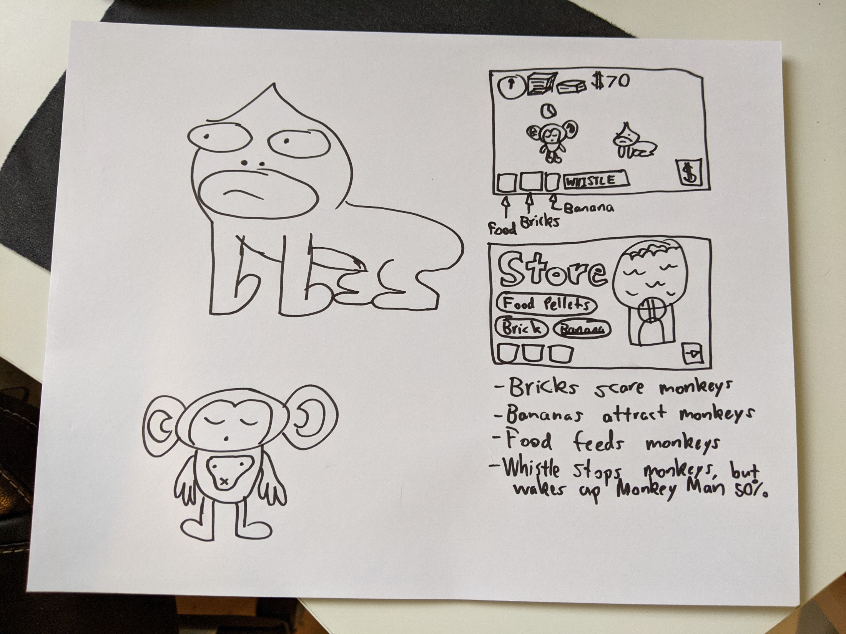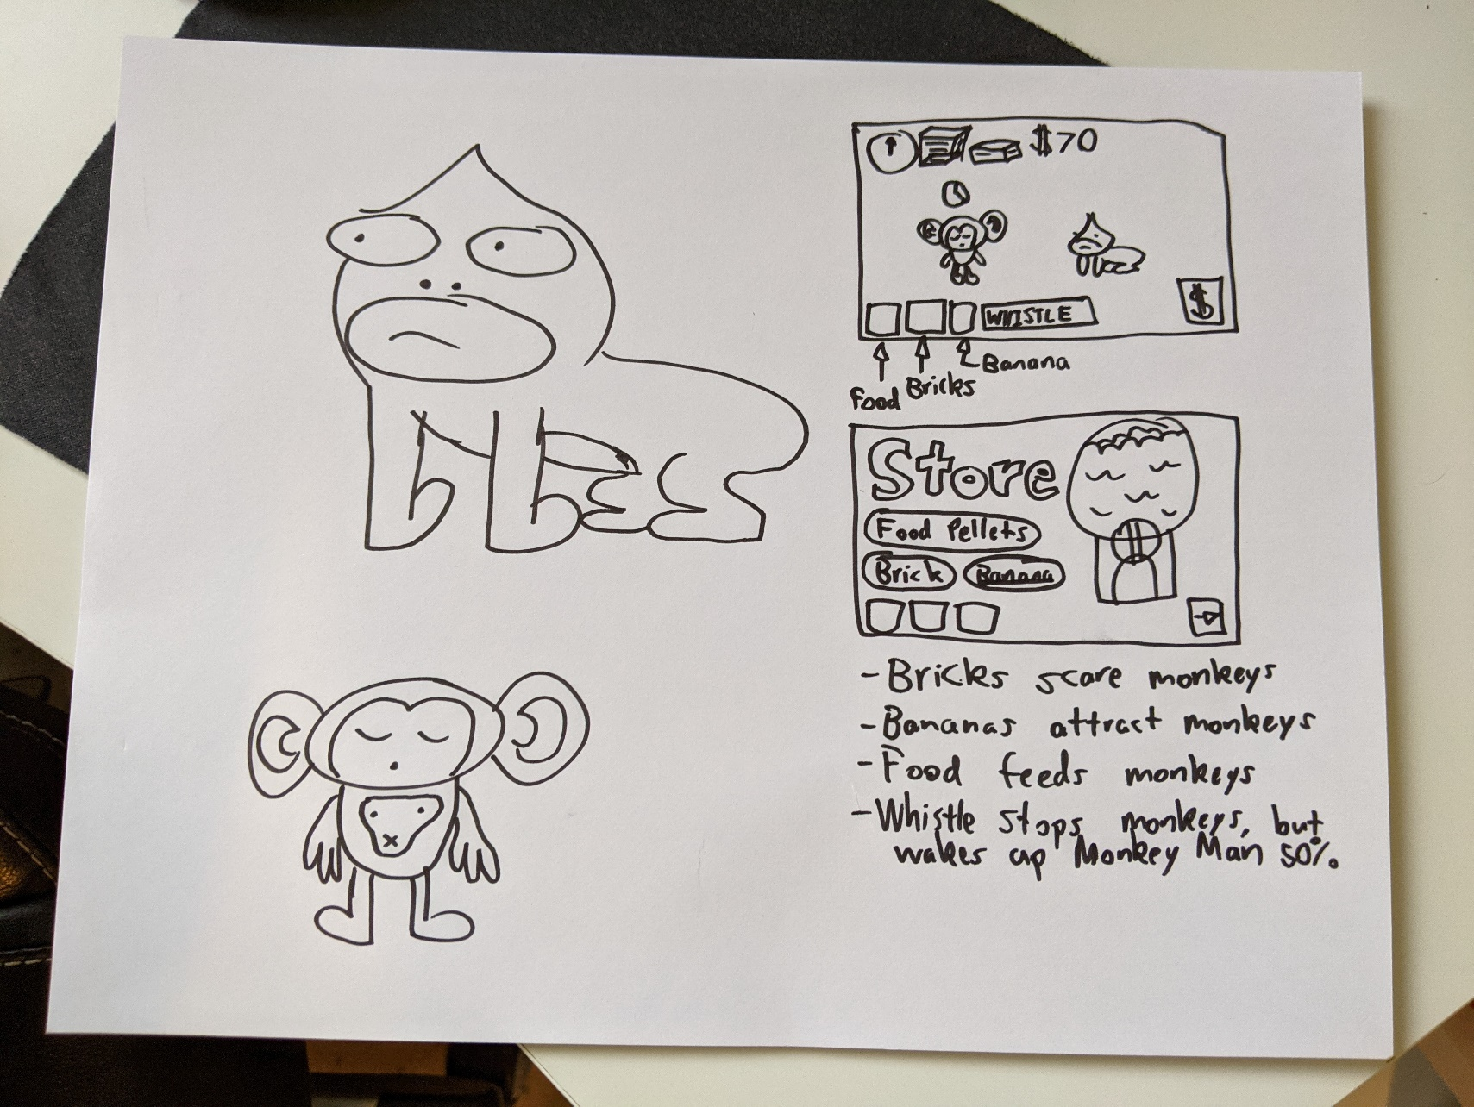

# Gameplay Loop

Protect human in monkey suit from the monkeys using supplies -> Gain money through wages -> Purchase supplies -> Repeat.

# Win Condition

Making it to the end of the day while keeping the human asleep and fed.

# Lose Condition

Human wakes up or starves to death.

# Obstacles

If a monkey gets too close to the human, the human will start to wake up. There will be a bar above the player that will deplete as the human becomes more awake. If human is woken up, the game ends.

Human needs to be fed with food pellets, which are in limited supply and also attract monkeys if thrown within range. When low an indicator above the human shows hunger.

Zoo visitors can be seen walking around the enclosure. They will randomly throw supplies into the exhibit. Player must counteract their effects using their own supplies if needed.

# Actions

## Throwables

Throw food pellets – Throw into enclosure to feed human. Both monkeys and human are attracted to this. Shows area of effect before throwing.

Throw brick – Throw into enclosure to scare monkeys. Wakes up human if thrown near to. Shows area of effect before throwing.

Throw banana – Throw into enclosure to attract monkeys (not human). Shows area of effect before throwing.

## Shop

Can purchase supplies (food pellets, bricks, bananas).

## Other

Whistle – Stops monkeys and makes them move toward player. Wakes up human partially.

# Replayability

2 different zoos. Higher level one has more monkeys and higher frequency of disruptions.